Week 14 – Web Scraping – In-class Exercises
Example 1: FiveThirtyEight
https://raw.githubusercontent.com/fivethirtyeight/data/master/college-majors/all-ages.csv
- Use download.file() to save this csv to your local computer

Example 2: Social Security data
https://www.ssa.gov/oact/babynames/numberUSbirths.html
- In R script
  - Use rvest to extract the html table
  - Save it as a RDS file
- In Quarto file: Read RDS file, clean, and analyze

Example 3: State populations (Wikipedia)
https://simple.wikipedia.org/wiki/List_of_U.S._states_by_population
- In R Script
  - Use rvest to extract the html table
  - Save it as RDS file
- In Quarto file:
  - Read in RDS file
  - Clean (select & rename relevant columns)
  - Use states <- map_data("state") to read in data for mapping
  - Join to the Wikipedia table and create a heat map using ggplot() + geom_polygon()
Example 4: PSSA
https://www.education.pa.gov/DataAndReporting/Assessments/Pages/PSSA-Results.aspx
- In R Script
  - Use rvest to extract the English Language Arts results table
  - Use rvest to extract the Math results table
  - Combine the two & save as RDS
- In Quarto file: read in the data & explore with visualizations
Your Turn Example: Olympic record progression
https://en.wikipedia.org/wiki/100_metres_at_the_Olympics
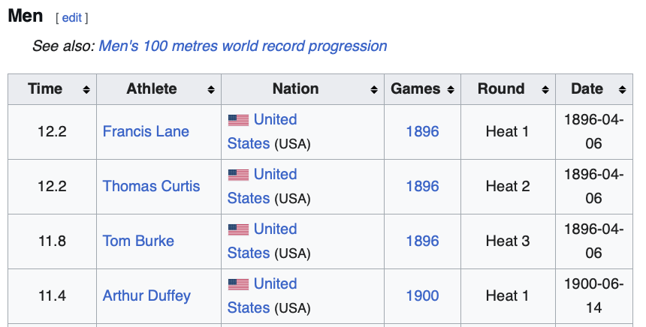
- In R Script
  - Use rvest to extract the Men’s 100 meters Olympic record progression (first few rows shown here)
  - Use rvest to extract the Women’s 100 meters Olympic record progression
  - Combine the two & save as RDS
- In Quarto file: read in the data & recreate the following visualization

